**Kentucky Library Association**

**Government Documents Round Table**

**Fall Business Meeting**

**via Zoom**

**October 28, 2020**

**In attendance:**

* Amy Laub-Carroll
* Crystal Ellis
* Claudene Sproles
* Marcia Johnson
* Deana Groves
* Philip Yannarella
* Pat Yannarella
* Rosemary Mezaros
* Lisa Beatty
* Mykie Howard
* John Schlipp
* Bruce Miracle
* Claudia Fitch
* Jennifer Horne
* Cris Ferguson
* Amelia Thomas
* Mike Wells

**Announcements:**

**LFPL-** Still not open to the public. Have not resumedDepository Services, but still offering Exchange

**NKU-** Closed from middle of March until Aug. 4th. Several vacancies. Most business done via chat.

**WKU**- Only circulation floor is open.

**UofL-** The Research Assistance and Instruction Department (RAI) developed a Citizen Literacy Toolkit. **Citizen Literacy** is an online toolkit that promotes the development of key information skills for democratic citizenship and features short videos, handouts, and activities that faculty across all disciplines can integrate into their courses and assignments. Available at:

<https://library.louisville.edu/citizen-literacy/home>

Make sure you check out **Amy Laub-Carrolls’** new article published in *Collaborative Librarianship*:

[https://digitalcommons.du.edu/collaborativelibrarianship/vol12/iss2/3](https://nam03.safelinks.protection.outlook.com/?url=https%3A%2F%2Fdigitalcommons.du.edu%2Fcollaborativelibrarianship%2Fvol12%2Fiss2%2F3&data=04%7C01%7Cclaudene.sproles%40louisville.edu%7C4a820d715ec5449863e708d87a931d56%7Cdd246e4a54344e158ae391ad9797b209%7C0%7C0%7C637394119558899971%7CUnknown%7CTWFpbGZsb3d8eyJWIjoiMC4wLjAwMDAiLCJQIjoiV2luMzIiLCJBTiI6Ik1haWwiLCJXVCI6Mn0%3D%7C1000&sdata=JUNWNE%2F8suCPOx8Z3RQBmRLdQvpB7ijJ5OHUCpOpfzg%3D&reserved=0)

The American Bar Association just released a free digital cookbook to honor the 19th Amendment expanding the universal right to vote.

<https://19thamendmentcookbook.com/cookbook/cookbook.pdf>

**Approval of Minutes of Fall Meeting**

* approved

**Secretary/Treasurer’s Report**

* 15 members
* $225.11

**Regional Librarian’s Report**

*News from the Regional:*

* The Federal Depository Unit at the University of Kentucky is still working remotely the majority of the time
  + The Regional Depository Librarian and the Library Technician Senior each began working on campus for 4 hours per week beginning Monday, August 3
* Due to budget constraints and the need for social distancing, we do not have any student assistants this fiscal year
* Because we are not working on campus full-time and are not employing student assistants, we are asking Selectives to email the Regional Depository Librarian prior to submitting Offers lists and to submit Offers only on Fridays, Mondays, or Tuesdays in order to make our in-building work more manageable

*ASERL Disposition Database:*

* On Monday, July 27, activities in the ASERL Documents Disposition Database resumed after a more than four-month hiatus.
  + All Offers that had been suspended from expiring from the Database since March expired on September 10 (45 days after the July 27 resumption of activity)
* The option to offer unlimited amounts from stems we no longer collect retrospectively continues to work well. For a list of these stems, check our offers guidelines. Remember to offer these materials on a different day than other Offers. You may offer this material even during an Offers hiatus since we do not check our collection for this material.
* Because of the need to catch up on in-building tasks and the upcoming holidays, there will be an Offers hiatus beginning, Tuesday, December 1 and ending, Sunday, January 3. If this will cause undue difficulty for your depository operations please email the Regional Depository Librarian ([amy.laub-carroll@uky.edu](mailto:amy.laub-carroll@uky.edu))

*ASERL Centers of Excellence (COE) at UK:*

* Along with other depository collection development, work has resumed on our three COE collections (WPA, ARC, and Smithsonian).

*News for Selectives:*

* GPO is asking all depository libraries to fill out this form whenever there are any changes in their operating status. In order to resume receiving shipments you will need to submit this form.
* We only use FDLP eXchange as a national needs and offers tool. Using FDLP eXchange is voluntary for Kentucky Selective Depositories and is only allowed after your offers expire in the ASERL Documents Disposition Database. If you do opt to use FDLP eXchange, we ask that you send Amy an email (amy.laub-carroll@uky.edu) letting her know you have submitted a list and the date you originally submitted that list to the ASERL Documents Disposition Database.

**Discussion on how to promote/display government publications**

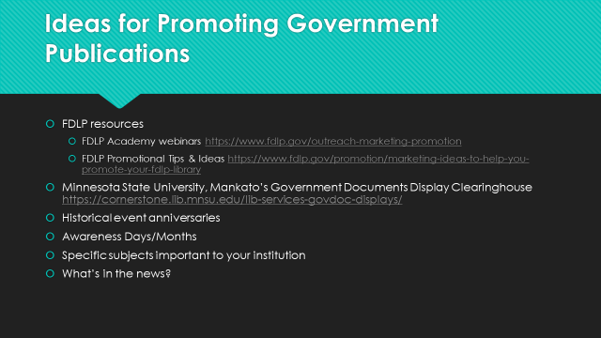

**Discussion on what we, as a roundtable, want to accomplish in the next year**

* Updating the KY GODORT Webpage
* Writing an article for KY Libraries
* Historic documents displays
* Send an email out to the listserv for ideas.

Respectfully Submitted,

Claudene Sproles

KY GODORT Secretary/Treasurer